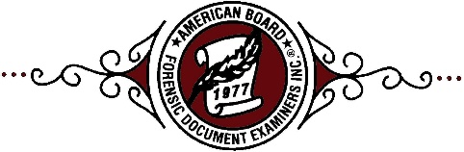
American Board of
Forensic Document Examiners, Inc.

I

Administrative Office:
7887 San Felipe
Suite 122
Houston, TX 77063
(713) 784-9537

Board of Directors

President
Ted M. Burkes
203 Edgehill Drive
Locust Grove, VA 22508

Vice President
Meg O’Brien
23512 Belvoir Woods Terrace
Ashburn, VA 20148-7492

Secretary
Miriam Angel
LAPD/FSD
1800 Paseo Rancho Castilla Suite 528
Los Angeles, CA 90032

Treasurer
Katherine Schoenberger
17841 Spyglass Hill Dr.
Strongsville, OH 44136

Additional Directors

John Barnett
Lisa Hanson
Alan Kreitl
George Lehman
Sandra Raudabaugh
Thomas Riley
Farrell Shiver

